**Mongo DB Task**

1. **Find all the information about each products**

db.products.find()

Output:

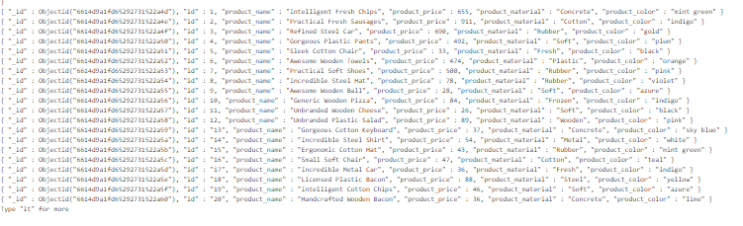

1. **Find the product price which are between 400 to 800**

db.products.find({$and: [{product_price: {$gte: 400.00}}, {product_price: {$lte: 800.00}}]})

Output:

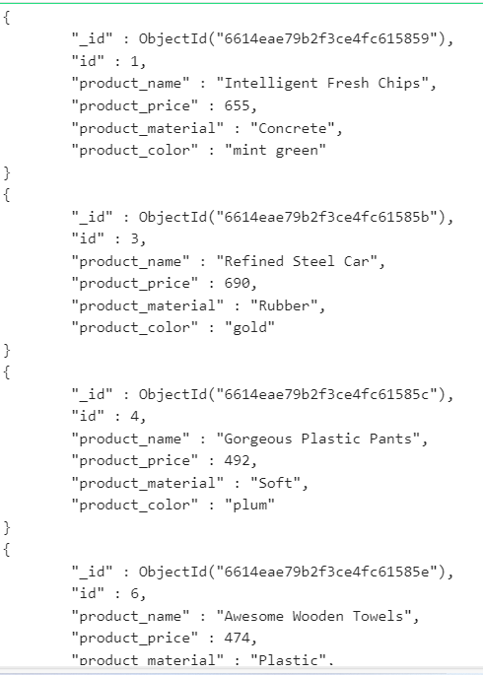

1. **Find the product price which are not between 400 to 600**

db.products.find({$or: [{product_price: {$lte: 400.00}}, {product_price: {$gte: 800.00}}]}).pretty()

Output:

1. **List the four product which are greater than 500 in price**

db.products.find({product_price: {$gte: 500.00}}).limit(4).pretty()

Output:

1. **Find the product name and product material of each products**

db.products.find({},{_id:0,product_name:1, product_material:1}).pretty()

Output:

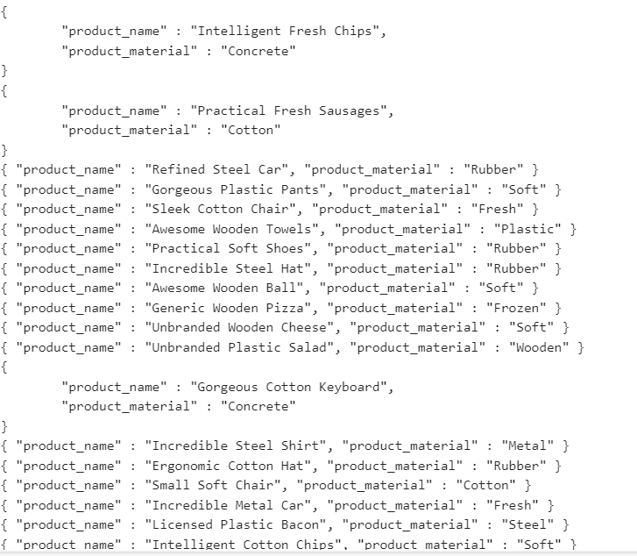

1. **Find the product with a row id of 10**

db.products.find({id: 10}).pretty()

Output:

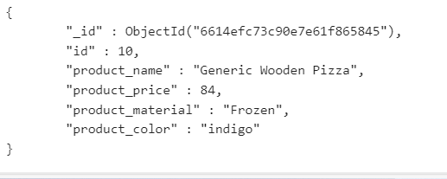

1. **Find only the product name and product material**

db.products.findOne({},{product_name:1,_id:0, product_material:1})

Output:

1. **Find all products which contain the value of soft in product material**

db.products.find({product_name : {$regex: "Soft"}}).pretty();

Output:

1. **Find products which contain product color indigo and product price 492.00**

db.products.find({$and: [{product_color: {$eq: "Indigo"}}, {product_price: {$eq: 492.00}}]}).pretty()

Output:  
 No result.  
 The product with price 492.00 has color as plum.

1. **Delete the products which product price value are 28**

db.products.deleteOne({id:28})

Output:

